**Ideation Phase**

**Brainstorm & Idea Prioritization Template**

|  |  |
| --- | --- |
| Date | 27 – June-2025 |
| Team ID | LTVIP2025TMID30752 |
| Project Name | Sustainable Smart City Assistant Using IBM Granite LLM |
| Maximum Marks | 4 Marks |

**Brainstorm & Idea Prioritization Template:**

Enhance urban sustainability and citizen engagement through AI-driven interfaces using IBM Watsonx, Pinecone, and Streamlit.

**Step-1: Team Gathering, Collaboration and Select the Problem Statement**

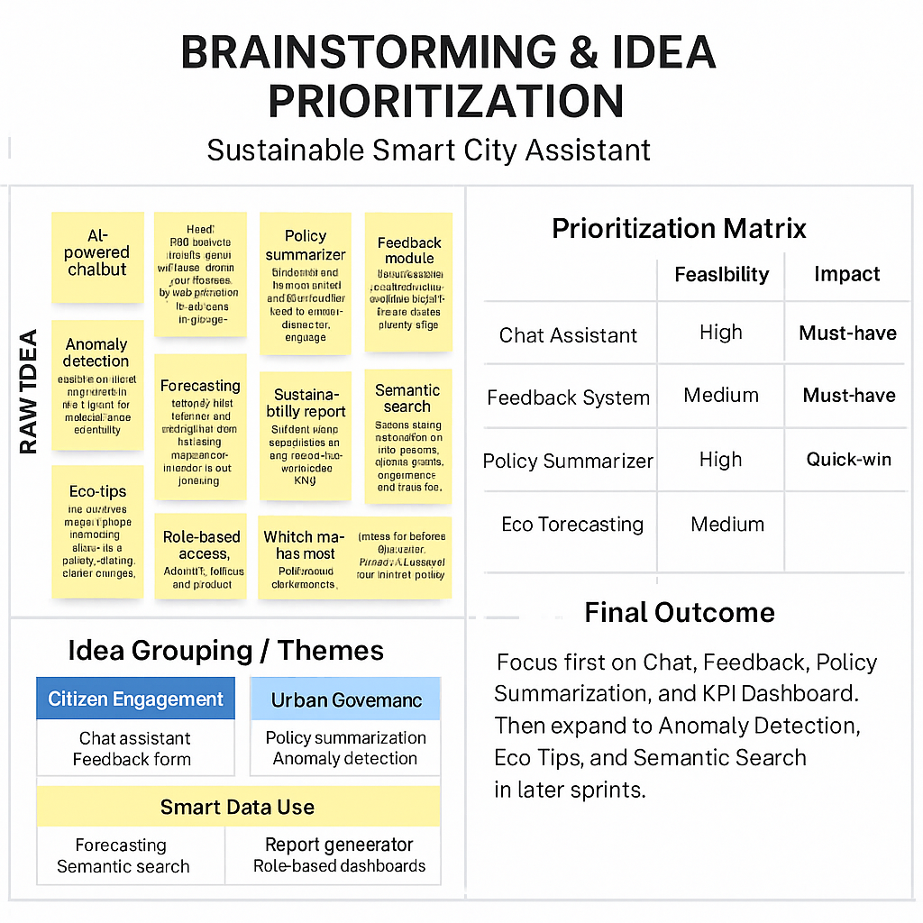

**Step-2: Brainstorm, Idea Listing and Grouping**

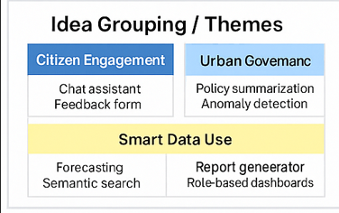

**Step-3: Idea Prioritization**



